Introduction
The high bit rates that result from the various types of digital video make their transmission through their intended channels very difficult. Even entertainment video with modest frame rates and dimensions would require bandwidth and storage space far in excess of that available from common storage devices such as a CD-ROM. Thus delivering consumer quality video on compact disc would be impossible. Similarly the data transfer rate required by a video telephony system is far greater than the bandwidth available over the plain old telephone system (POTS).

1.1 Need for Video Compression
Even if high bandwidth technology e.g. fiber-optic cable was in place, the per-byte-cost of transmission would have to be very low before it would be feasible to use it for the staggering amounts of data required by HDTV. Finally, even if the storage and transportation problems of digital video were overcome, the processing power needed to manage such volumes of data would make the receiver hardware very expensive.
Digital video compression entails the utilization of many coding techniques with the ultimate goal to reduce the size of the digital representation of a video sequence. In video coding, the fact that subsequent video frames do not differ much can be similarly exploited in order to increase compression efficiency.

1.2 Coding Techniques
All coding techniques can be categorized into two main categories, namely
- Lossy and
- Lossless techniques.
Lossy coding techniques remove pel information that the human eye is unable to perceive using coding techniques such as discrete cosine transform and quantization. The information that has been removed in most cases cannot be exactly regained, but it usually can only be approximated. On the other hand, lossless coding techniques do not remove any information. Instead, it exploits redundancies, i.e., similarities, between pels found in and between video frames which results in the representation of pel information using fewer bits.
A lossless coding technique is predictive coding which predicts current pel(s) using reference pel(s) and then store the difference(s) between the prediction and the current pel(s). Assuming redundancy between pels, the differences are usually small and can be coded using fewer bits than the coding of the original pels. Predictive coding can use pels from the same video frame as reference pels (intra-coding) or pels from other video frames (inter-coding).
Inter-frame predictive coding can contribute to the overall compression efficiency, because consecutive video frames are usually similar, i.e., they do not differ much. In this sense, the reference pels can be found in a reference frame located at the same position as the current pels in the current to be coded frame. This approach can also be used to capture scene changes by choosing the reference frames in the near future of the current (to be encoded) frame instead from its past. However, such a straightforward approach has one major drawback. Objects in a video scene tend to move around resulting in poor compression performance of the straightforward inter-frame predictive coding method, because pels located at the same location in consecutive frames are now quite different.
Although significant gains in storage, transmission, and processor technology have been achieved in recent years, it is primarily the reduction of the amount of data that needs to be stored, transmitted, and processed that has made widespread use of digital video a possibility. This reduction of bandwidth has been made possible by advances in compression technology.
Compression reduces the bandwidth required to transmit and store digital video.

1.3 Motion Estimation
Motion estimation has been introduced in an attempt to capture the motion of objects within a video scene i.e., find the best match between the pel(s) in the current frame and the pel(s) in the reference frame. To this end, a search area within the reference frame must be traversed in order to find the best match. After finding the best match, the difference(s) between the pels must be coded together with the difference between the locations (motion vector).
Motion estimation can be performed for single pels in the current frame, but it is rarely used, because the coding of motion vectors for single pels reverses the gains of predictive coding. Therefore, block-based motion estimation is the most commonly used form in which a search is performed in the reference frame for a block of pels in the current frame.
Two key issues are associated with motion estimation in general, namely the size of the search area and which metric to use for determining the ‘best match’. The first issue is an interesting one, because a limited search area reduces the possibility of finding a ‘best match’ and an exceedingly large search area results in many unnecessary computations. In order to reduce the number of computations, many search area traversing methods. The second issue relates to finding a metric that will guarantee a good coding performance.
Two of such metrics are the
- Mean square error (MSE) and
- Mean absolute difference (MAD).

1.4 Basics of Video Compression
A video is composed of a set of frames. Two consecutive frames have a high degree of correlation and this is utilized for video compression. While transmitting the video, only the first frame and the difference between every consecutive frame are sent, thereby reducing the overall data transmitted. Hence, the transmission bandwidth is reduced and compression is achieved.

SAD Algorithm

2.1 Mathematical representation
Considering the block-based motion estimation is most commonly used in multimedia standards, the block-based forms of the MSE and the MAD metrics are calculated as follows:
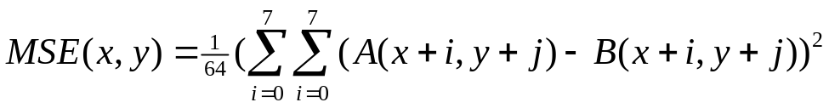 (2.1)
With 0 ≤ x, y < frame size
With A_{(x, y)} being a current frame pel at (x, y)
With B_{(x, y)} being a reference frame pel at (x, y)
Due to square operation on the differences, this operation is less commonly used. Instead, MAD is used more often and is calculated as follows:
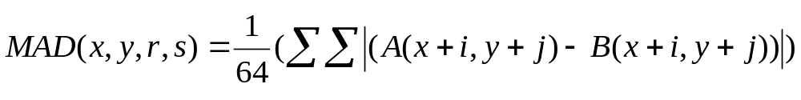 (2.2)
With 0 ≤ x, y < frame size
With A_{(x, y)} being a current frame pel at (x, y)
With B_{(x, y)} being a reference frame pel at (x, y)
The vector (x, y) denotes the location to be encoded block in the current frame. Due to the computational simplicity of the MAD, it is being used more often than the MSE.
The MAD can be rewritten to:
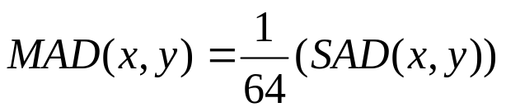
(2.3)
The division by 64 in computer arithmetic is translated into an easy shifting the final SAD result by 6 bits. All the absolute operations of the SAD operation can be performed serially, per column in parallel, per row in parallel, or all 64 operations in parallel. While it is possible to perform all the operations serially, this approach is time-consuming and not efficient performance-wise. Performing the operations per row or per column in parallel are exactly the same with the only difference being the indexing of the pels. The completely parallel approach is a simple extension of the per-row or per-column approaches, considering 8×1 SAD that processes all the pels in a row in parallel. An additional advantage of the row parallel approach is because the pel data is stored in consecutive locations in the main memory. The complete SAD operation can be rewritten to:
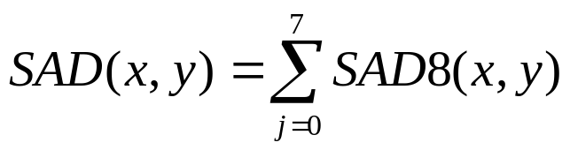
(2.4)

With the SAD8 being defined as:
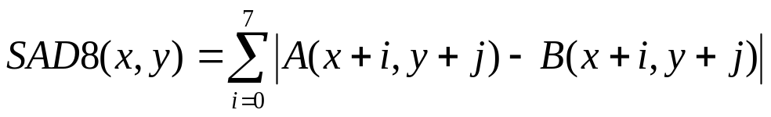 (2.5)
With 0 ≤ x, y < frame size
With A_{(x, y)} being a current frame pel at (x, y)
With B_{(x, y)} being a reference frame pel at (x, y)

2.2 Practical implementation

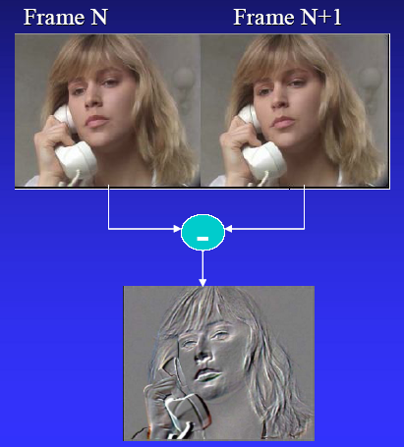
Fig 1: Pictorial Representation of SAD
Consider the above two consecutive frames. Since there is a high degree of correlation between the two frames, we need not transmit both the images. Only the difference is computed and SAD is used as a metric to represent this redundancy. The difference image as shown above represents only the slight change in motion between the two images. The absolute value is taken and the corresponding absolute differences and summed. This gives the SAD value.
First, the columns of the difference image are added and this represents the corresponding SAD value. The lower the SAD value, it implies the two images are similar in that pixel area. A SAD value of 0 represents that the two images are identical. The other SAD values are assessed based on a threshold and then if the SAD values are higher than the threshold, it implies that the two images are entirely different and hence, that data has to be transmitted.
Consider the 2D difference matrix (n * m)
……….

S1 S2 S3 S4 S5 S6 S7 S8……… Sm
Fig 2: Difference Matrix representation (N * M)
Here, these sums S1- Sm represent the SAD values of each column. The lower the SAD value, it implies that the correlation is more and hence the data is similar. Hence, this redundancy can be reduced by not transmitting the existing columns again. This entire procedure is carried out in ten steps as described below.
SAD is a metric, usually used in motion estimation and related algorithms. Here, we use it to indicate the redundancy of the pixels so that similar ones can be eliminated and only those which differ by a considerable amount need to be transmitted.
Hence, in this way, the bandwidth can be saved and to attain higher compression ratios, the threshold can be increased so that less number of columns needs to be transmitted. But if the threshold is made very large, it is possible that a significant amount of data will be lost. To ensure that these is less data loss as well as to attain a good compression ratio, the threshold was set to be 75% of the maximum gray scale values of the sums S1 – Sm. Hence, in this way compression is attained.

The Compression Procedure

3.1 Basic Principle
First the video is represented in frames (still images). Consider the first two frames
Frame 1
(m * n * o)
Frame 2
(m * n * o)
-

Difference Frame
(m * n * o)

Text file
(Binary values)

Array in MODELSIM (thresholding)

O/p = Column numbers in difference matrix

Fig 3: flow chart for basic principle of Compression procedure
The above procedure is carried out in 10 steps which are explained briefly and the corresponding programs are at the end of the document- at the appendix.

3.2 Steps to perform Video Compression
- Convert the Video into frames
- Read the frames in MATLAB
- Perform the absolute difference of the 2 frames
- Write this output in a text file
- Read this text file in MODELSIM
- The values from this file are stored in an array
- The first n values (n = no of rows) are summed & the resultant (m = no of columns) values are stored in another array
- Based on a threshold, the higher values are selected
- This value represents the column no. in the matrix
- The columns are replaced from the difference file and then the reconstructed image is obtained by adding the difference file to frame1

STEP 1 - Convert the Video into frames
A video is taken and divided into its corresponding frames using Pinnacle Studio Software. The detailed explanation of how this is done is explained in the Pinnacle Studio section. Here, the concept that each frame is similar to its previous and next frame is used. The entire video of 16 sec is divided into frames with a time gap of 18 ms and 27 such frames are obtained.
Video
Frames
Pinnacle studio

STEPS 2, 3, 4 - Read the frames in MATLAB and perform the absolute difference of the 2 frames & Write this output in a text file
The frames are read in MATLAB software using the function ‘imread’. Each frame is 300 * 400 *3 pixels long here. The entire program is mentioned in the Appendix. The flow chat is elaborated below
Read Frames -1, 2
(m * n * o)

Convert the 3D Images to 2D
(m * n * o) → (m * n)

Reshape the matrices to columns
(m * n) → (mn * 1)

Take the absolute difference

Convert gray scale to binary values
Write these binary values to a text file using 2 loops

Output = text file with binary values to be read in MODELSIM

Fig 4: Procedure to read the frames and convert it to a binary value text file
Read Frames - 1, 2
This is performed by using the function “imread”. This function reads a grayscale or color image from the file specified. The images are either in .png (portable networks graphics) or .bmp (bitmap) or other image readable formats. The syntax of the above operation is
I = imread (‘filename.bmp’);
Convert the 3D Images to 2D
The last dimension of the matrix is deleted by assigning the 3rd dimension to an empty matrix. This converts the 3D image to a 2D one.
I (:, :, 1:1:2) = [ ];
Reshape the matrixes to a column matrix
This is done by using the function “reshape”. The syntax is given be
B = reshape (I, 1, nzmax (I));
Here, the function “nzmax” give the amount of storage allocated for nonzero matrix elements.
Take the absolute difference
The difference of the two matrices is performed using the operator “-“(minus sign). The absolute value is taken using the function “abs”.
D = F1 – F2;
A = abs (D);
Convert the gray scale values to binary values
This is performed using the function ‘dec2bin”.
C = dec2bin (A);
Write these binary values to a text file using 2 loops
Two loops are used here. One loop is used to read each line i.e. each bit of the binary values (horizontally) and another loop is used to read the entire matrix i.e. values from the beginning to the end of the file. Then, a new text file is created and all the values are read as strings and written in the text file. The syntaxes are given below
fid = fopen ( ‘output.txt’, ’w + b’)
The variable fid is used to indicate file indicator and the name of the text file is specified along with the mode which is write cum binary mode in this case.
fprintf (fid, ’%s\n’, l);
This is similar to the C language function and writes the formatted data to the text file. S indicates that the values are written as strings and \n indicates a newline.

STEP 5 - Read this text file in MODELSIM
The values from this text file are read in MODELSIM using VHDL using the textio library. The entire program is shown in the appendix. First, the file is read to a variable using the function “readline” and then every line i.e. value is read from variable using the function “read”.

STEP 6 - The values from this file is stored in an array
The text file’s values are written in an array based on the logic
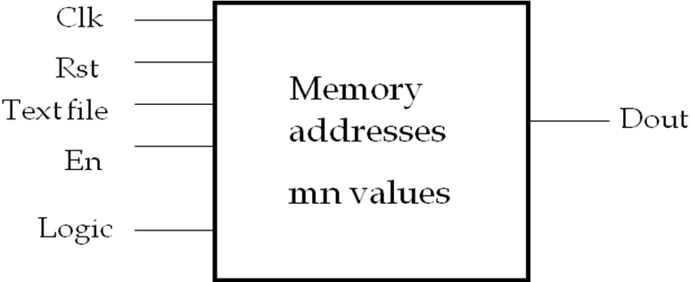
Fig 5: Block diagram to represent how values are stored in an array
First, the enable is set to start the process. At every positive edge of the clock, one value is read from the file and stored in a temporary array. Next, the logic is such that the first n values are summed and stored. Hence, we get such m sums as the output.

STEPS 7, 8 - The first n values are summed & the resultant m values are stored in another array & Based on a threshold, the higher values are selected
Now, out of these m values, only those which are above a threshold value must be taken and hence this filtering is done using a threshold. To get a good compression ratio, the threshold is selected as
Threshold = Max value out of the m values * 0.75
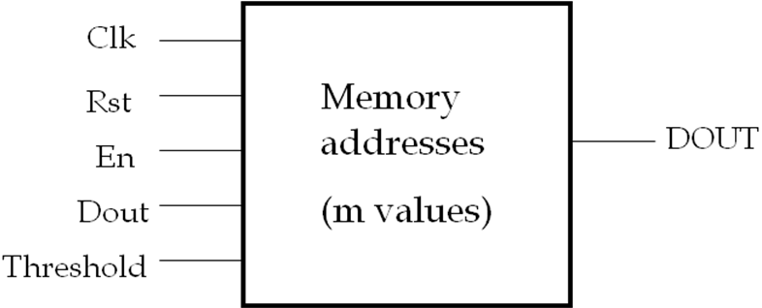
Fig 6: Block diagram to represent the filtering using threshold on inputs
Hence, the output is a few values out of m values. This signifies the column numbers in the difference matrix (m * n) and these are to be transmitted instead of all the m columns.

STEPS 9, 10 – The corresponding column no. is replaced in difference file and then the reconstructed image is obtained by adding the difference file to frame1
All the values which are filtered out based on the threshold are ignored and the remaining values indicate the column numbers of the difference to be sent to the receiver. Hence, again in MATLAB, we create a (m * n) matrix of zeros and then the columns with the corresponding column numbers are replaced in this zero matrix. This is the new difference matrix. This matrix is then added to the corresponding previous frame to get the reconstructed image.

Pinnacle Studio

4.1 Introduction
Hollywood FX is a powerful editor of 3D transitions, titles and animated effects. Since 1994 this software has provided many of the same capabilities as broadcast television equipment and high-end compositors. It gives one an incredible collection of 3D transitions that one can quickly add to our video productions, and completely customize to ones needs.

4.2 The Software
Pinnacle Studio is a non-linear video editing software application manufactured by Pinnacle Systems, a division of Avid Technology. It is the consumer level counterpart to Pinnacle's former professional level software, Liquid Edition (now Avid Liquid). It also inherits from VOB Computer system’s Instant CD/DVD. Studio allows users to author video content, create VCD/DVDs with menus and burn them without the need for any additional software.

4.3 Features
One can access all sorts of media such as television, radio, music, movies and photos from the computer. Also, one can watch both analog and digital television on the computer or on the television screen. One can have immediate access to news using teletext and a lot other options are available using this software.
Other features such as Picture-in-Picture allow the user to watch multiple TV channels simultaneously. This PIP feature also displays two or more TV windows, allowing one to view and record multiple TV channels simultaneously.

4.4 Advantages
Avid Pinnacle Studio Plus 10 does its best to erase the distinctions between consumer and prosumer video-editing tools by delivering flexible tools for both. But it spreads itself too thin, making it the also-ran for either market: Ulead Video Studio 9 is a smarter option for video newbies who want to dive right in, while Adobe's impressive Premiere Elements 2 offers more precise control and professional-level features for those who will take the time to learn them.
Studio Plus makes a niche for itself by offering video editing that's simple enough for beginners but with plenty of room to grow. The recommended requirement is a 2.4GHz system, and the more power the better. The Liquid engine ported from Pinnacle's higher-end products seems to demand nothing less for smooth performance. The program has a new Background Save feature ensured that we don’t lose work when there is no power.
Pinnacle Studio may be purchased separately, but is also included in bundled packages with various video capture hardware devices. These include analog and digital capture, either as PCI cards or connection via USB. Recently, Pinnacle released new versions of their Movie box devices, including HDV and AVCHD support, shipped with their new Studio products.
In addition, a cut-down SE version entitled Pinnacle Studio Quick Start was included with the Dazzle (another USB capture device) and Pinnacle PCTV products, though since the release of Studio 12, the Quick Start version has been discontinued; Dazzle Video Creator Platinum now ships with the regular basic version of Studio, and the PCTV products ship with Video Spin

4.5 Versions
Pinnacle was previously associated with Adobe, but that association is no longer. After the disassociation, Pinnacle released a liquid beta version that required minimum system requirement. Since version 9, Studio has been sold in two editions: Studio and Studio Plus, with some additional functionality in the Plus edition, notably a second video track. This allowed Overlay and Picture-in-Picture.
Studio 10 and Studio 10 Plus were released on the 17 August 2005. While retaining the same user interface as Studio 9, the code base was taken from Liquid Edition, now called Avid Liquid. Real time preview at full resolution was introduced along with the ability to mix PAL, NTSC, 4:3 and 16:9 footage on the timeline. The standard version of Studio 10 has fewer features than the standard version of Studio 9, but Studio 10 Plus offers further enhancements including HD editing. Version 10.7 Plus allows users (after purchasing a premium feature) to burn High Definition video to standard DVD media that will then replay on the Toshiba HD-DVD players. Vista compatibility was added in version 10.8.
Pinnacle released Studio 11 in June 2007. It features three versions: Studio, Studio Plus, and Studio Ultimate. All three are designed to be compatible with Windows Vista and feature a new scalable interface and replace Smart sounds music generation with Score fitter, a midi-based version written in-house.
Studio 11 Plus added native HDV and AVCHD editing, and HD DVD from standard discs. Key framing became possible on most effects. Bluray AVCHD to standard DVDs was added in S11.1.1.
Pinnacle Studio Ultimate became the new top-of-the-line consumer video editing application. It included Soundsoap PE, an advanced sound-cleaning tool, Dolby 5.1 Surround encoding, proDAD VitaScene, and Moving Picture, a precision pan and zoom. A green-screen sheet to produce the chroma key effects with is also included in the full Ultimate version, or can be purchased separately.
Studio 12 was released in June 2008. Enhancements to the editing features include markers that can be placed on the timeline "on the fly", improved audio controls and the addition of Montage, which allows multi-layered video and still composites to be generated within pre-defined templates. MOD import and FLV output was added, as was direct upload to YouTube (similar to arch-competitors iMovie and Adobe Premiere Elements).
The Plus and Ultimate versions also add full Blu-ray disc burning with menus. Ultimate comes with Vitascene as in S11, but replaces Soundsoap and Moving Picture with Boris Graffiti 5.1 and Magic Bullet Looks SE. A new addition is the Content Transfer Window which should allow you to import any plug-ins or premium content purchased for Studio 10 or 11.
While Pinnacle Studio is revered for its user-friendly GUI, all recent releases are well-known to frequently crash. This is especially true when the project undergoes the rendering process.

4.5 VideoSpin
In the second half of 2007, Pinnacle introduced VideoSpin, a freely downloadable non-linear video editor similar to Studio but with several features missing. Some of the missing features include the storyboard, the ability to capture digital and analogue video, the video and audio toolboxes, the SmartSound/Scorefitter music generator, SmartMovie capabilities and DVD burning. Projects created in VideoSpin may be opened and edited in Pinnacle Studio 11, though not vice-versa, and once a project has been loaded in Studio, it may not again be reloaded in VideoSpin.
An advanced codec pack can be purchased allowing users to use MPEG-2, MPEG-4 and DiVX codec’s, all of which are available freely for the first 15 days after installation. VideoSpin is also included with the Pinnacle PCTV products, replacing Studio QuickStart.
Since Pinnacle released the "patch" for Studio 12, several of the effects paid for in RTFX Volume 1 no longer worked. This was due to the parameters of the effects being changed from type="VideoFilter" HostMask="2" to type=VideoFilter" Hide. It was written this way for the following effects: Bevel Crystal, Lens Flare, Magnify, Median, Mosaic, Replicate, Water Drop, and Water Wave.

4.6 Implementation of Pinnacle Studio
Any video is composed of frames and any two consecutive frames have a high degree of correlation. This concept is exploited here and we represent the video in its corresponding frames. Here, a 16.22 seconds video was selected and 27 frames were captured at the rate of 1 frame in 18 ms. In this way, the 27 frames were captured and saved on disk.
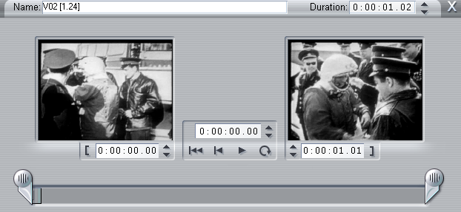
Fig 7: A video sequenced read in Pinnacle Studio
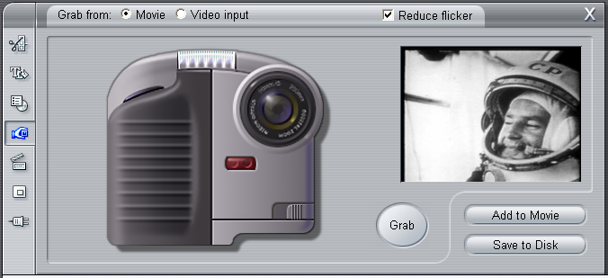
The general layout of this editing software is shown above. The video was first broken down into 9 parts each of which was 1:24 seconds long and then the frames were obtained. Each frame is quite similar to its previous one. Demonstrated below is how the frames are captured and stored.

Fig 8: Frame Grabber tool
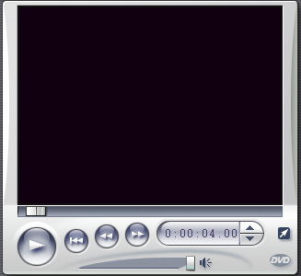
The frames are grabbed at which ever time the user wants and then stored. Here, the duration was 18ms i.e. each frame was captured at a gap of 18 units. Then the video is taken and sequenced in the following box

Fig 9: Video Capture box
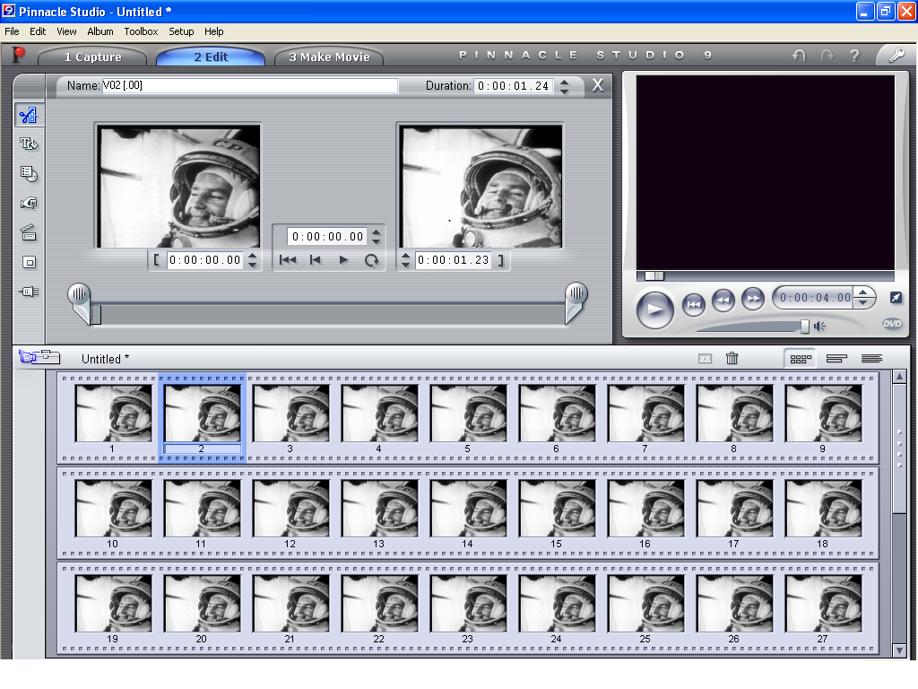
Fig 10: Software showing how the frames are got from a video
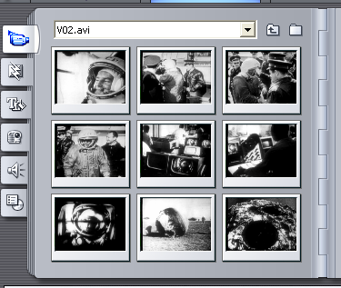
After capturing all the frames, they are represented in the software using the following dialog box as shown.

Fig 11: the 9 parts of the video
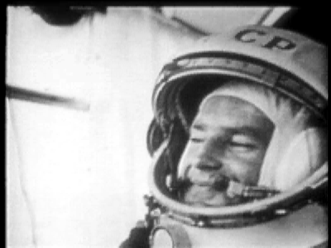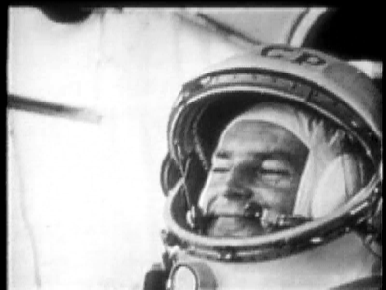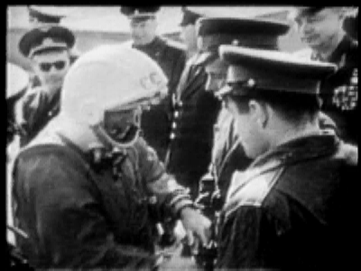
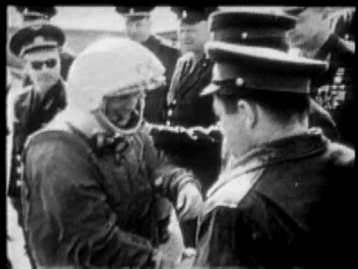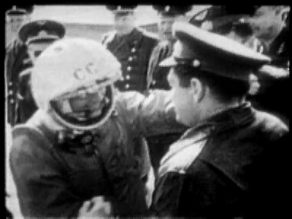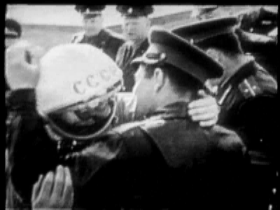
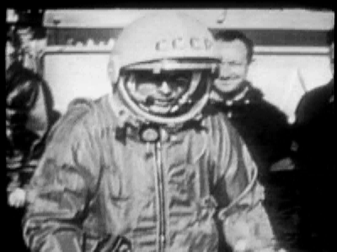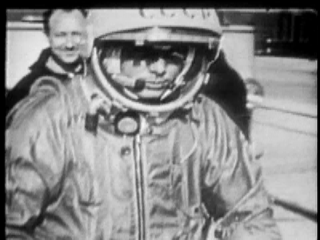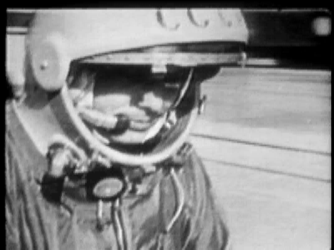
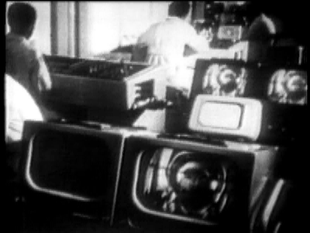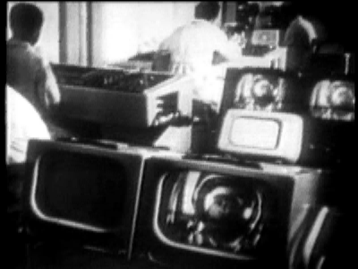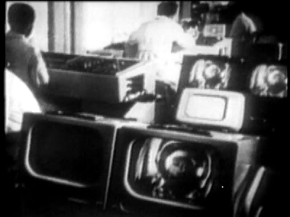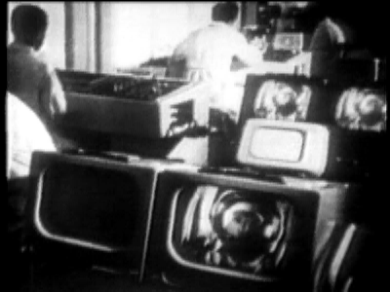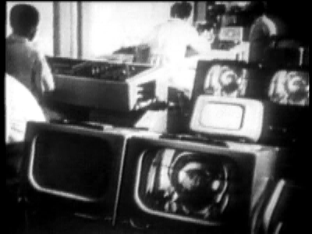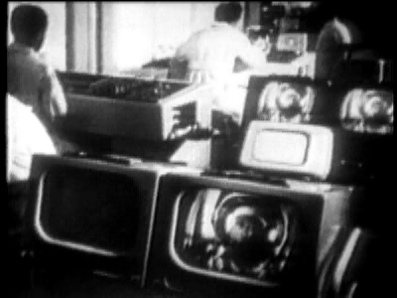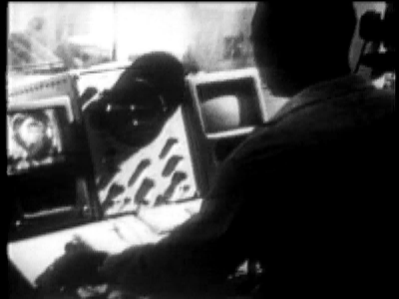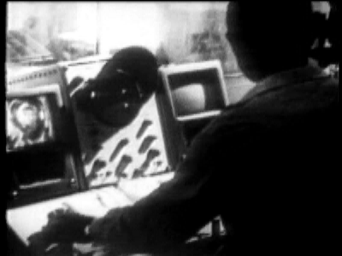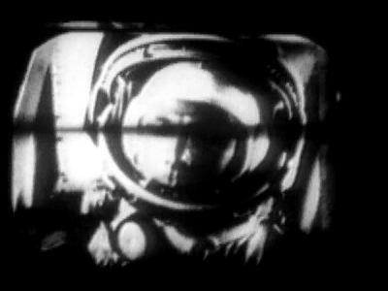
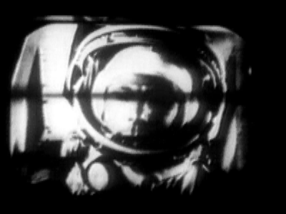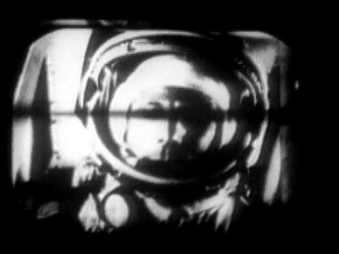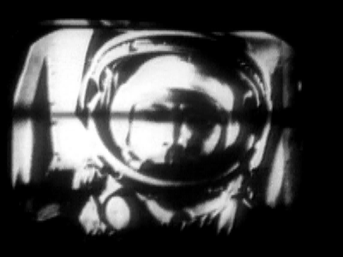
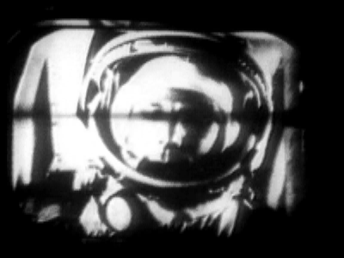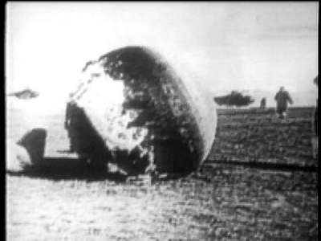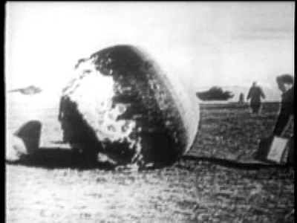
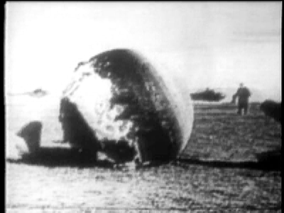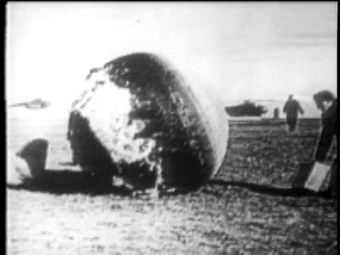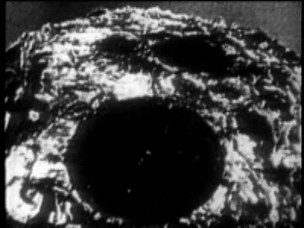
Fig 12: The final 27 frames of the space video
So the first step is done using this software and the frames are captured. The next few steps require MATLAB which is explained later.

Matlab
MATLAB is a numerical computing environment and programming language. Maintained by The MathWorks, MATLAB allows easy matrix manipulation, plotting of functions and data, implementation of algorithms, creation of user interfaces, and interfacing with programs in other languages.
Although it is numeric only, an optional toolbox uses the MuPAD symbolic engine, allowing access to computer algebra capabilities. An additional package, Simulink, adds graphical multidomain simulation and Model-Based Design for dynamic and embedded systems. In 2004, MathWorks claimed that MATLAB was used by more than one million people across industry and the academic world.

5.1 Introduction
Matlab (Matrix laboratory) is an interactive software system for numerical computations and graphics. As the name suggests, Matlab is especially designed for matrix computations: solving systems of linear equations, computing eigen values and eigenvectors, factoring matrices, and so forth. In addition, it has a variety of graphical capabilities, and can be extended through programs written in its own programming language. Many such programs come with the system; a number of these extend Matlab's capabilities to nonlinear problems, such as the solution of initial value problems for ordinary differential equations.
Matlab is designed to solve problems numerically, that is, in finite-precision arithmetic. Therefore it produces approximate rather than exact solutions, and should not be confused with a symbolic computation system (SCS) such as Mathematica or Maple. It should be understood that this does not make Matlab better or worse than an SCS; it is a tool designed for different tasks and is therefore not directly comparable.

5.2 Developments
MATLAB (meaning "matrix laboratory") was invented in the late 1970s by Cleve Moler, then chairman of the computer science department at the University of New Mexico. He designed it to give his student’s access to LINPACK and EISPACK without having to learn Fortran. It soon spread to other universities and found a strong audience within the applied mathematics community.
Jack Little, an engineer, was exposed to it during a visit Moler made to Stanford University in 1983. Recognizing its commercial potential, he joined with Moler and Steve Bangert. They rewrote MATLAB in C and founded The MathWorks in 1984 to continue its development. These rewritten libraries were known as JACKPAC. In 2000, MATLAB was rewritten to use a newer set of libraries for matrix manipulation, LAPACK
MATLAB was first adopted by control design engineers, Little's specialty, but quickly spread to many other domains. It is now also used in education, in particular the teaching of linear algebra and numerical analysis, and is popular amongst scientists involved with image processing

5.3 Syntax
MATLAB is built around the MATLAB language, sometimes called M-code or simply M. The simplest way to execute M-code is to type it in at the prompt, >> , in the Command Window, one of the elements of the MATLAB Desktop. In this way, MATLAB can be used as an interactive mathematical shell. Sequences of commands can be saved in a text file, typically using the MATLAB Editor, as a script or encapsulated into a function, extending the commands available

5.4 Variables
Variables are defined with the assignment operator, =. MATLAB is dynamically typed, meaning that variables can be assigned without declaring their type, except if they are to be treated as symbolic objects, and that their type can change. Values can come from constants, from computation involving values of other variables, or from the output of a function.

5.5 Vectors/Matrices
MATLAB is a "Matrix Laboratory", and as such it provides many convenient ways for creating vectors, matrices, and multi-dimensional arrays. In the MATLAB vernacular, a vector refers to a one dimensional (1×N or N×1) matrix, commonly referred to as an array in other programming languages. A matrix generally refers to a 2-dimensional array, i.e. an m×n array where m and n are greater than 1. Arrays with more than two dimensions are referred to as multidimensional arrays.
Indexing is one-based, which is the usual convention for matrices in mathematics. This is atypical for programming languages, whose arrays more often start with zero.
Matrices can be defined by separating the elements of a row with blank space or comma and using a semicolon to terminate each row. The list of elements should be surrounded by square brackets: []. Parentheses: () are used to access elements and subarrays (they are also used to denote a function argument list).

5.6 Semicolon
Unlike many other languages, where the semicolon is used to terminate commands, in MATLAB the semicolon serves to suppress the output of the line that it concludes. That is to say: if a statement is not terminated with a semicolon, then the result of the statement is displayed. A statement that does not explicitly return a result, for instance 'clc', will behave the same whether or not a semicolon is included.
Additionally, a semicolon may be used within a vector or matrix declaration in order to separate rows (as opposed to a comma which separates columns within the same row). For example, a row vector will be declared as r = [1,2,3]. On the other hand a column vector will be c = [1;2;3].

5.7 Graphics
Function plot can be used to produce a graph from two vectors x & y.

5.8 Limitations
For a long time there was criticism that because MATLAB is a proprietary product of The MathWorks, users are subject to vendor lock-in. Recently an additional tool called the MATLAB Builder under the Application Deployment tools section has been provided to deploy MATLAB functions as library files which can be used with .NET or Java application building environment. But the drawback is that the computer where the application has to be deployed needs MCR (MATLAB Component Runtime) for the MATLAB files to function normally. MCR can be distributed freely with library files generated by the MATLAB compiler.
MATLAB, like Fortran, Visual Basic and Ada, uses parentheses, e.g. y = f(x), for both indexing into an array and calling a function. Although this syntax can facilitate a switch between a procedure and a lookup table, both of which correspond to mathematical functions, a careful reading of the code may be required to establish the intent.
MATLAB lacks a package system, like those found in modern languages such as Java and Python, where classes can be resolved unambiguously, e.g. Java's java.lang.System.out.println(). In MATLAB, all functions share the global namespace, and precedence of functions with the same name is determined by the order in which they appear in the user's MATLAB path and other subtle rules. As such, two users may experience different results when executing what otherwise appears to be the same code when their paths are different.
Many functions have a different behavior with matrix and vector arguments. Since vectors are matrices of one row or one column, this can give unexpected results. For instance, function sum(A) where A is a matrix gives a row vector containing the sum of each column of A, and sum(v) where v is a column or row vector gives the sum of its elements; hence the programmer must be careful if the matrix argument of sum can degenerate into a single-row array. While sum and many similar functions accept an optional argument to specify a direction, others, like plot, do not, and require additional checks.
There are other cases where MATLAB's interpretation of code may not be consistently what the user intended (e.g. how spaces are handled inside brackets as separators where it makes sense but not where it doesn't, or backslash escape sequences which are interpreted by some functions like fprintf but not directly by the language parser because it wouldn't be convenient for Windows directories). What might be considered as a convenience for commands typed interactively where the user can check that MATLAB does what the user wants may be less supportive of the need to construct reusable code.
Array indexing is one-based which is the common convention for matrices in mathematics, but does not accommodate any indexing convention of sequences that have zero or negative indices. For instance, in MATLAB the DFT (or FFT) is defined with the DC component at index 1 instead of index 0, which is not consistent with the standard definition of the DFT in any literature. This one-based indexing convention is hard coded into MATLAB, making it difficult for a user to define their own zero-based or negative indexed arrays to concisely model an idea having non-positive indices.
M-code written for a specific release of MATLAB often does not run with earlier releases as it may use some of the newer features. To give just one example: save('x','filename') saves the variable x in a file. The variable can be loaded with load('filename') in the same MATLAB release. However, if saved with MATLAB version 7 or later, it cannot be loaded with MATLAB version 6 or earlier. As workaround, in MATLAB version 7 save('x','filename','-v6') generates a file that can be read with version 6. However, executing save('x','filename','-v6') in version 6 causes an error message.

5.9 Interactions with other languages

5.9.1 Calling C and Fortran functions
MATLAB can call functions and subroutines written in C programming language or Fortran. A wrapper function is created allowing MATLAB data types to be passed and returned. The dynamically loadable object files created by compiling such functions are termed "MEX-files", although the file name extension depends on the operating system and processor.

5.9.2 Interactions with Java and ActiveX
Libraries written in Java or ActiveX can be directly called from MATLAB and many MATLAB libraries (for example XML or SQL support) are implemented as wrappers around Java or ActiveX libraries. Calling MATLAB from Java is more complicated, but can be done with MATLAB extension, which is sold separately by MathWorks.

5.9.3 Interactions with other Mathematics Software Packages
Through the MATLAB Toolbox for Maple, MATLAB commands can be called from within the Maple Computer Algebra System, and vice versa.

5.9.4 Alternatives
Matlab has a number of competitors in the field of numerical analysis software. Two examples are GNU Octave and FreeMat which are Open Source alternatives intended to provide, at least limited, compatibility with the Matlab language. A more complete list of Matlab's competitors, both open source and commercial, can be found at the Wikipedia list of numerical analysis software and comparison of numerical analysis software.
MATLAB is available for a number of environments: Sun/Apollo/VAXstation/HP workstations, VAX, MicroVAX, Gould, PC and AT compatibles, 80386 and 80486 computers, Apple Macintosh, and several parallel machines
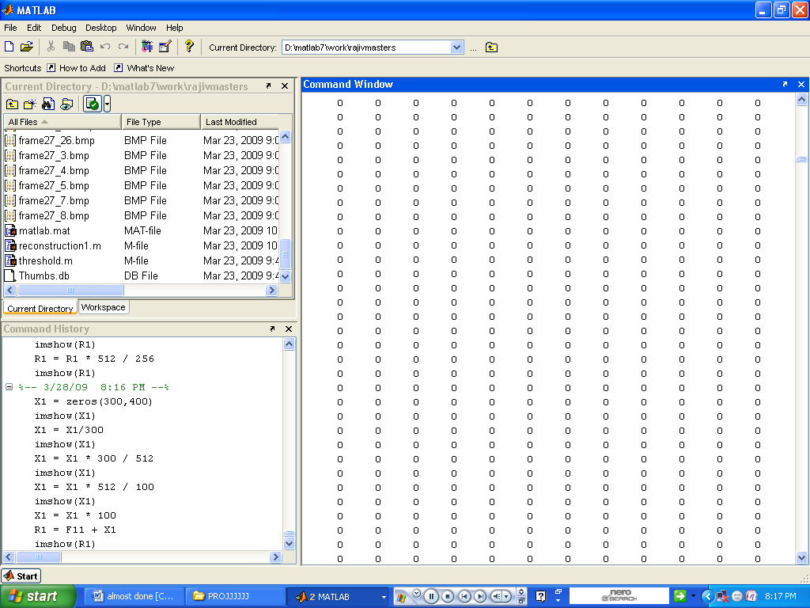
Fig 13: Matlab Sotware

Modelsim

6.1 Introduction
ModelSim is a verification and simulation tool for VHDL, Verilog, SystemVerilog, and mixed language designs.
The modelsim simulation environment is divided into four:
- Basic simulation flow
- Project flow
- Multiple library flow
- Debugging tools

- Basic Simulation Flow
The following diagram shows the basic steps for simulating a design in ModelSim
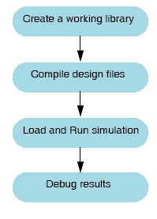
Fig 14: Flow chart for simulation of overview lab

- Creating the Working Library
In ModelSim, all designs are compiled into a library. A new simulation is started in ModelSim by creating a working library called "work". "Work" is the library name used by the compiler as the default destination for compiled design units.

• Compiling the Design
After creating the working library, compilation of the design units into it. The ModelSim library format is compatible across all supported platforms. Simulation of the design can be done on any platform without having to recompile the design.

• Loading the Simulator with the Design and Running the Simulation
With the design compiled, one should load the simulator with the design by invoking the simulator on a top-level module (Verilog) or a configuration or entity/architecture pair (VHDL). Assuming the design loads successfully, the simulation time is set to zero, and the run command is entered to begin simulation.

• Debugging Your Results
If the results are not as expected, ModelSim’s robust debugging environment can be used to track down the cause of the problem.

- Project Flow
A project is a collection mechanism for an HDL design under specification or test. Even though projects need not be used in ModelSim, they may ease interaction with the tool and are useful for organizing files and specifying simulation settings. The following diagram shows the basic steps for simulating a design within a ModelSim project.
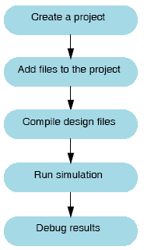
Fig 15: Project flow in VHDL
The flow is similar to the basic simulation flow. However, there are two important differences:
• One need not create a working library in the project flow; it is done automatically.
• Projects are persistent i.e. they will open every time ModelSim is invoked unless specifically closed.
- Multiple Library Flow
ModelSim uses libraries in two ways:
1) as a local working library that contains the compiled version of the design;
2) as a resource library.
The contents of the working library will change as design is updated and recompiled. A resource library is typically static and serves as a parts source for the design. One can create their own resource libraries, or they may be supplied by another design team or a third party (e.g., a silicon vendor). One has to specify which resource libraries will be used when the design is compiled, and there are rules to specify in which order they are searched. A common example of using both a working library and a resource library is one where the gate-level design and testbench are compiled into the working library, and the design references gate-level models in a separate resource library. The diagram below shows the basic steps for simulating with multiple libraries.
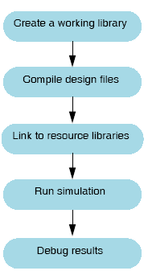
Fig 16: The basic steps of simulating with Multiple Libraries
Resource libraries can also be linked from within a project.
Debugging Tools
ModelSim offers numerous tools for debugging and analyzing your design.

VHDL
(VERY HIGH SPEED INTEGRATED CIRCUIT HARDWARE
DESCRIPTION LANGUAGE)

7.1 Introduction
An HDL (Hardware Description Language) is a software programming language used for modeling the intended operation of a piece of hardware.

7.2 A brief description of VHDL
VHDL, which stands for VHSIC (Very High Speed Integrated Circuit) Hardware Description Language, was developed in the early 1980s as a spin –off of a high speed integrated circuit research project funded by the U.S Department of Defense. The first publicly available version of VHDL, version 7.2, was released in 1985. In 1986, the Institute of Electrical and Electronics Engineers, Inc. (IEEE) was presented with a proposal to standardize the language, which it did in 1987 after substantial enhancements and modifications were made by a team of commercial government and academic representatives. The resulting standard, IEEE 1076-1987, is the basis for virtually every simulation and synthesis product sold today. An enhanced and updated version of the language, 1076-1993 was released in 1994, and VHDL tool vendors have been responding by adding these new language features to their products.

7.3 VHDL
VHDL – Very High Speed Integrated Circuit Hardware Description Language
VHDL is similar to programming languages C and C++ and includes features useful for control and data representation. In addition, VHDL provides features that allow the description of concurrent events and important aspect of VHDL is its ability to capture the circuit performance specification in a form commonly referred to as test bench. The test benches are VHDL descriptions of circuit stimulus and corresponding expected outputs for the verification of circuit behavior.
VHDL has been designed and optimized for describing the behavior of digital circuits and systems. VHDL allows the behavior of complex electronic circuits to be captured into design systems of for system simulation. VHDL has features that allow electrical aspects of circuit behavior such as functional operations, gate delays and signal rise or fall times to be precisely described. The resulting VHDL simulation models can then be used as building blocks in large circuits (e.g. by using schematics or block diagrams) for simulation purposes.
It can describe the behavior and structure of electronic systems, but is particularly suited as a language to describe the structure and behavior of digital electronic hardware designs, such as ASICs and FPGAs as well as conventional digital circuits.
The VHDL language can be regarded as an integrated amalgamation of the following languages:
Sequential language +
Concurrent language +
Net list +
Timing specifications +
=> VHDL
Therefore, the language has constructs that enable you to express the concurrent or sequential behavior of a digital system with or without timing. It also allows you to model the system as an interconnection of components. Test waveforms can also be generated using the same constructs. All the above constructs can be combined to provide a comprehensive decision of the system in a single model.
The language not only defines the syntax but also defines very clear simulation semantics for each language construct. Therefore, the models written in this language can be verified using a VHDL simulator. It is strongly typed language and is often verbose to write. It inherits many of its features, specially the sequential language part, from the Aria programming language. Because, VHDL provides an extensive range of modeling capabilities, it is often difficult to understand. Fortunately, it is possible to quickly assimilate a core subset of the language that is both easy and simple to understand without learning the more complex features. This subset is usually sufficient power to capture the descriptions of the most complex chips to a complete electronic system.

7.4 Levels of Description
VHDL is hardware description language that provides a very wide range of descriptions. VHDL provides several concurrent construct that relate more closely to real hardware design, including the description of hierarchy. VHDL provides specific constructs to define the structures or inter connectivity of hierarchical hardware designs. With the use of configuration declarations, a user can configure a design with different alternate architectures for its sub elements, thus allowing the analysis of various design alternatives.
When considering the application of VHDL to FPGA/ASIC design, it is helpful to identify and understand the three levels of description:
- Algorithmic level
- RTL level
- Gate level
Algorithms are not synthesizable, RTL is the input to synthesis, and gate level is the output from synthesis.

7.4.1 Algorithmic level:
A pure algorithm consists of a set of instructions that are executed in sequence to perform some task. Some aspects of timing can be inferred from the partial ordering of operations written in the algorithm. Some synthesis tools (behavioral synthesis) are available that can take algorithmic VHDL code as input, but the VHDL input may have to be constrained.

7.4.2 Register Transfer Level (RTL):
This level describes the registers and the Boolean combinational equations between the registers and used as an input to a logic synthesizer. It is also used to define state machines for a controller designs where the state registers may be both explicitly or implicitly defined on the declarations and coding style.

7.4.3 Gate level:
This level describes the structural interconnections of low-level elements (gates and flip-flops) of a design. It is generally an output of a synthesizer or a layout tool and is used either as a documentation of a net list, or as a VHDL model of the structural definition of a design for a VHDL simulation.
The following are some of the major attributes of high-level behavioral design language VHDL
- Modeling capability: The hardware behavioral modeling can be performed in VHDL
- Compilation: Compilation is a way of speeding simulation without changing the original nature of the language. Simulation results can change by simply changing the order of compilation. In VHDL, one can separately compile multiple design units(entity architecture pairs), which are in the same system file.
- Data types: In VHDL, one can use many language or user defined data types, which may require dedicated conversion functions to convert objects from one type to another. Therefore, one has to carefully consider the choice of which data type to use, especially with the enumerated(abstract) data types.
- Design reusability: In VHDL, the procedures and functions can be placed in the package so that there are available for general use by any other design unit.
- Structural replication: The generate statement in VHDL replicates a number of instances of the same design unit or the same sub elements of a design and connects them appropriately.
- Low level and high level constructs: The VHDL has simple two input logical operators built into the language such as NOT, AND, OR, NAND, NOR, XOR, XNOR etc. Timing must be specified separately using the ‘after’ clause. One needs to use separate constructs defined in IEEE 1076.4 VHDL initiate toward ASIC libraries(VITAL) standards to define the cell primitives of ASIC and FPGA libraries. The VHDL has more constructs and features for high level modeling. In VHDL, one can use the abstract data types along with the following statements: Model reuse, configuration design structure, generic statements for generic models that can be individually characterized. These language statements are useful in synthesizable models.
- Language extensions: The use of language extensions makes the model non standard and may affect the portability to other design tools. However, the extensions are sometimes necessary and in VHDL there is an attribute called ~foreign that allows modeling architectures and subprograms in another language.
- Libraries: In VHDL, a library is a storage area in the host environment for compiled entities, architectures, packages and configurations. An arbitrary number of design libraries may be specified. Each design library has a logical name with which it is referenced inside a VHDL description. For example a design library called IEEE, STD are predefined by language. This libraries support the basic operations which are required like arithmetic operations and type conversions.
- Managing large designs: The VHDL has configuration, generate and package statements along with generic clause to help and manage large designs structures.
- Procedures and tasks: The VHDL allows concurrent procedure calls.
- Attributes: An attribute is a value function type, range, signal or constant that can be associated with certain names within VHDL description. For example value attributes returns a constant value.
VHDL IS
- Nonproprietary language: VHDL is defined in IEEE 1076standard 1987 and IEEE 1076 standard 1993.
- Widely supported Hardware Description Language (HDL): Several vendors have adopted the standard and are supplying VHDL compilers, simulators and synthesis tools.
- Programming language: Sections of VHDL (similar to ADA) and include data types, packages, sequential statements, procedures, functions, control structures and file input-output.
- Simulation language: VHDL includes structures to define and simulate events, timing and concurrency.
- Documentation language: VHDL is capable of documenting instruction set architecture, state machines, structures and hardware design hierarchies.
- Usable for logic synthesis: VHDL provides constructs that imply hardware. The language is technology independent but allows user defined attributes to tailor the synthesis process into user-defined direction. There are several synthesis tools that read and convert VHDL code into a gate level description targeted towards specific technologies.
- Functional Verification language: VHDL defines the environment necessary to verify the units under test (UUTs) . This environment includes software or hardware models of the UUTs interfaces. It also includes a verifier model to verify the correct functionality of the UUTs when exposed to the stimuli.

7.5 Levels of Abstraction
- VHDL supports many possible styles of design description. These styles differ primarily in how closely they relate to the underlying hardware. When we speak of the different styles of VHDL, we are really talking about the differing levels of abstraction possible using the language – Behavioral, Dataflow, and Structural.

7.5.1 Behavioral
The highest level of abstraction supported in VHDL is called the behavioral level of abstraction. When creating a behavioral description of a circuit, the circuit is described in terms of its operation over time. The concept of time is the critical distinction between behavioral descriptions of circuits and lower-level descriptions (specifically descriptions created at the dataflow level of abstraction) are registers in you circuits. It is unlikely, however, that your synthesis tool will be capable of creating precisely the same behavior in actual circuitry as you have defined in the language. It is also unlikely that your synthesis tool will be capable of accepting and processing a very wide range of behavioral description styles.
Behavior-level VHDL is just like a programming language, where writing one or more small programs operate sequentially and communicate with one another through their interfaces. The only difference between behavior-level VHDL and a software programming language is the underlying execution platform: in the case of software, it is some operating system running on a CPU; in the case of VHDL, it is the simulator and/or the synthesized hardware.
The most powerful concurrent statement is the process statement. The process statement consists of sequential statements and allows designs to be described at the behavioral level of abstraction.
COMBINATIONAL LOGIC:
To describe combinational logic the general format of process statements is
Process(signal-name, signal-name, signal-name)
Begin

end process;
For combinational logic there is a list of all process input signals after the keyword process.
SEQUENTIAL LOGIC:
For sequential logic there is either
- no sensitivity list but there is wait statement.
- A sensitivity list containing the clock and the statements are within an if statement.
General form of sequential logic:
Process(clock-signal)
Begin
if clock-signal and clock-signal`event then
end if;
end process;
Several other statements which can be used in behavioral are variable and signal assignment , wait, if ,case, null, loop, exit, next ,assertion, report etc.

7.5.2 Dataflow
In the dataflow level of abstraction, the circuit is described in terms of how data moves through the system. At the heart of most digital systems today are registers, so in the dataflow level of abstraction you describe how information is passed between registers in the circuit. The combinational logic portion of the circuit at a relatively high level(and let a synthesis tool figure out the detailed implementation in logic gates) is described but we should be quite specific about the placement and operation of registers in the complete circuit.
The data flow level of abstraction if often called register transfer logic, or RTL. This level of abstraction is an intermediate level that allows the drudgery of combinational logic to be simplified(and, presumably , taken care of by synthesis tools) while the most important parts of the circuit, the registers, are more completely specified.
There are some drawbacks to using a dataflow model of design in VHDL. First, there are no built-in registers in VHDL; the language was designed to be general-purpose, and the emphasis was placed by the VHDL’s designers on its behavioral aspects. If you are going to write VHDL at the dataflow level of abstraction, you must first create(or obtain) behavioral descriptions of register elements you will be using in your design. These elements must be provided in the form of components(using VHDL’s hierarchy features) or in the form of subprograms(functions or procedures).
But for the hardware designers, it can be difficult to relate the sequential descriptions and operation of behavioral VHDL with the hardware being described(or modeled). For this reason, in many VHDL users, particularly those whose are using VHDL as an input to synthesis, prefer to stick with levels of abstraction that are easier to relate to actual hardware devices(such as logic gates and flip-flops). These users are often more comfortable using the dataflow level of abstraction.
In dataflow descriptions combinational logic is described with the signal assignment(<=). There is no register assignment operator. Sequential logic is inferred from incomplete specifications.

7.5.3 Structural:
The third level of abstraction, structure, is used to describe a circuit in terms of the components. Structure can be used to create a very low-level description of a circuit(such as a transistor-level description) or a very high-level description(such as a block diagram).
In a gate-level description of a circuit, for example, components such as basic logic gates and flip-flops might be connected in some logical structure to create the circuit. This is what is often called a net list. For a higher level circuit—one in which the components being are larger functional blocks—structure might simply be used to segment the design description into manageable parts.
Structure-level VHDL features, such as components and configurations, are very useful for managing complexity. The use of components can dramatically improve your ability to re-use elements of your designs, and they can make it possible to work using a top-down design approach. The components would be defined as entity or architecture.

Simulation Waveforms

8.1 Frames 1, 2
Threshold = 0000010011010110010
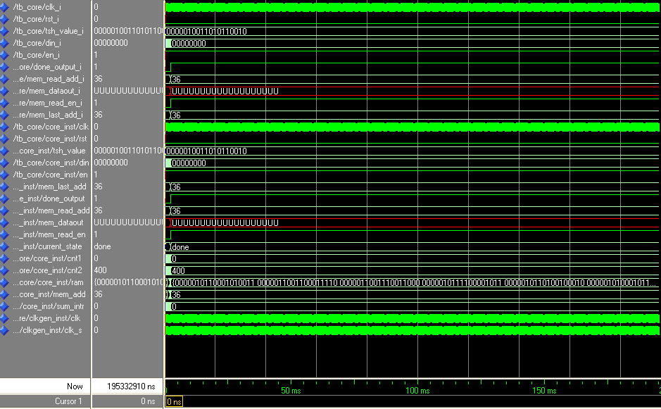
No of columns to be passed = 36

8.2 Frames 3, 4
Threshold = 0000010101010100100
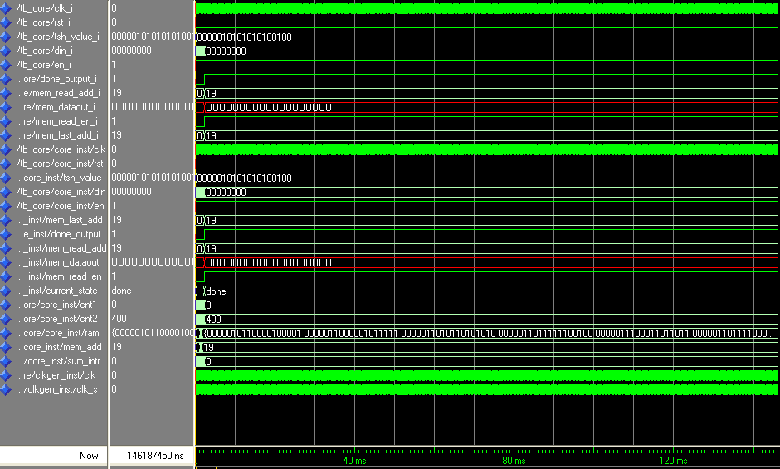
Number of columns to be passed = 19

8.3 Frames 4, 5
Threshold = 0000011010011001111
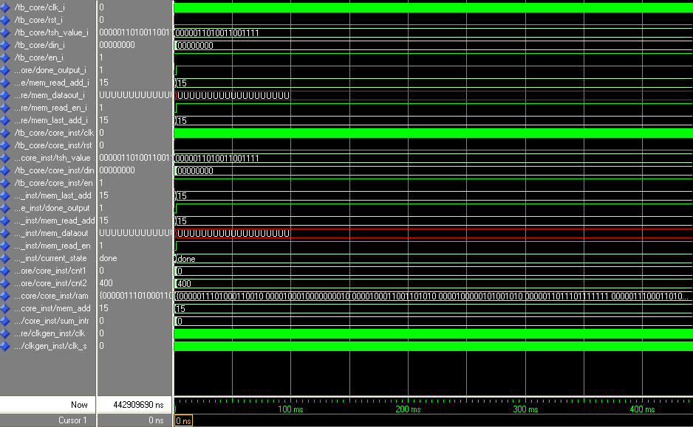
Number of columns to be passed = 15

8.4 Frames 7, 8
Threshold = 0000010011111011100
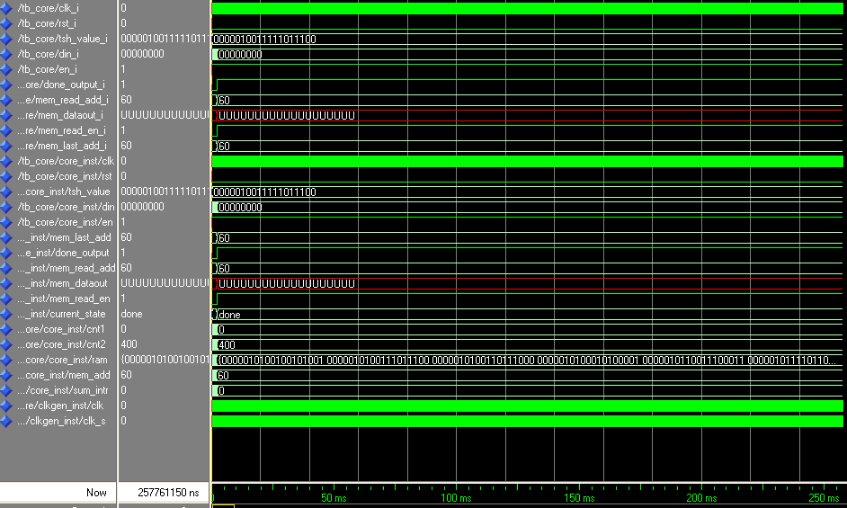
Number of columns to be passed = 60

8.5 Frames 10, 11
Threshold = 0000000010011101000
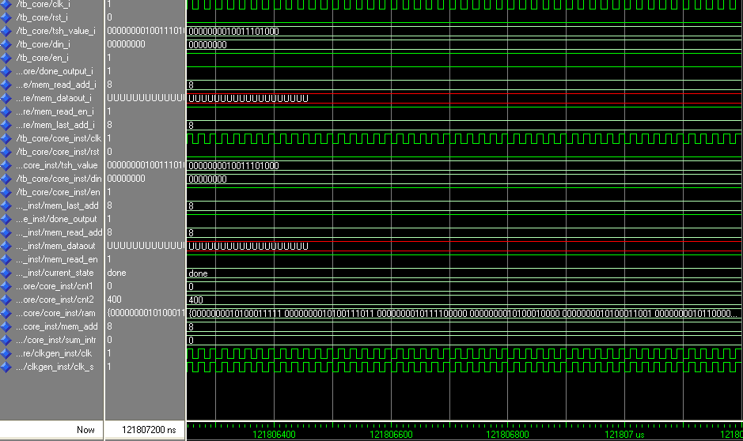
Number of columns to be passed = 8

8.6 Frames 11, 12
Threshold = 0000000100011010000
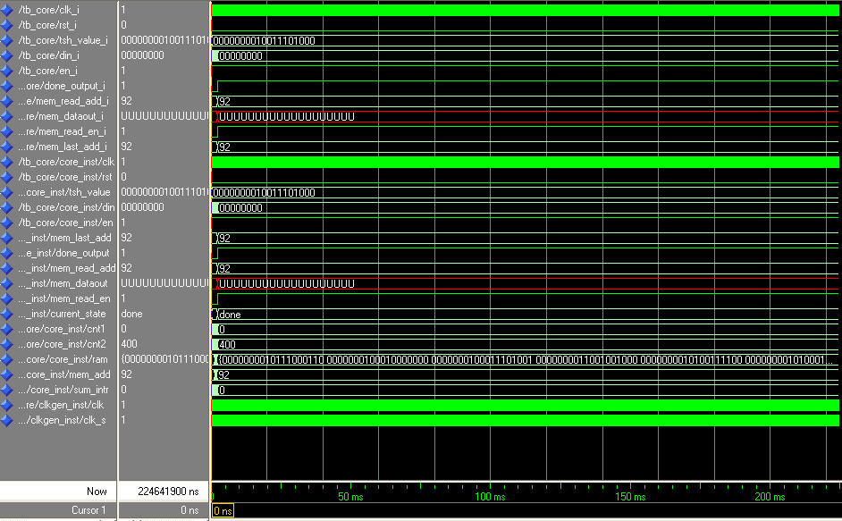
Number of columns to be passed = 92

8.7 Frames 12, 13
Threshold = 0000000010101111101
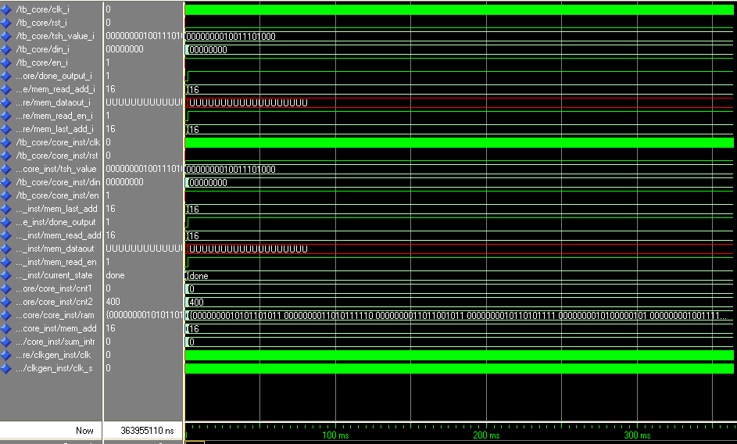
Number of columns to be passed =16

8.8 Frames 13, 14
Threshold = 0000000100001111100
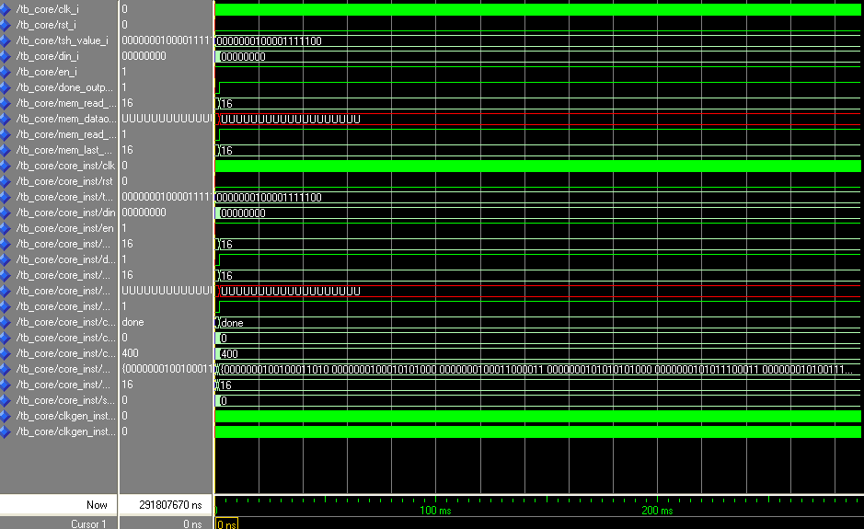
Number of columns to be passed =16

8.9 Frames 20, 21
Threshold = 0000000011101010011
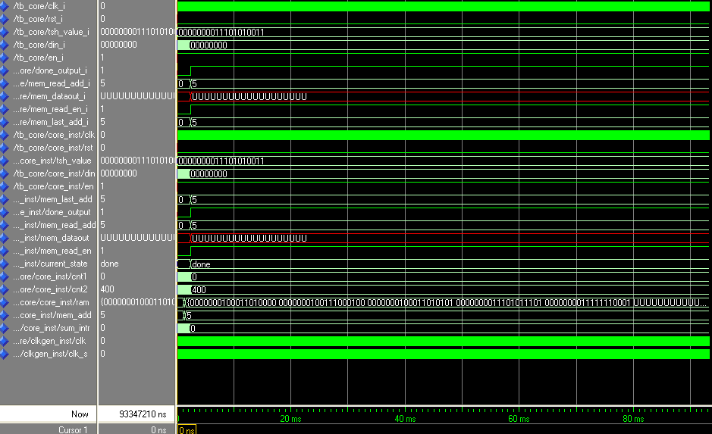
Number of columns to be passed = 5

8.10 Frames 25, 26
Threshold = 0000001011000101111
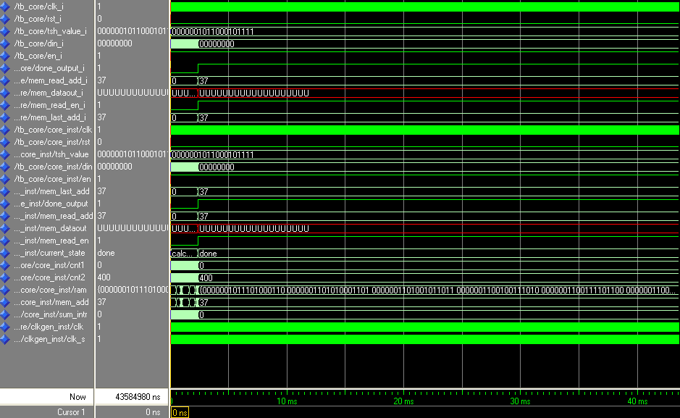
Number of columns to be passed =37

Reconstructed Frames

Here, a few reconstructed images are shown out of the 27 frames.

9.1 Reconstructed Frame 2

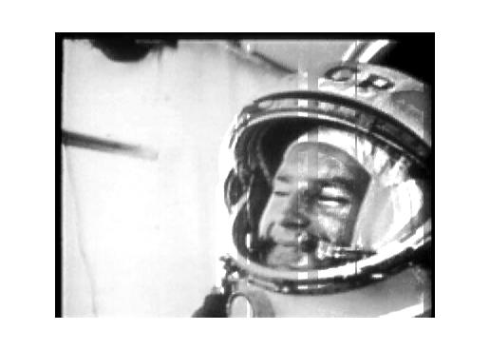

9.2 Reconstructed Frame 4

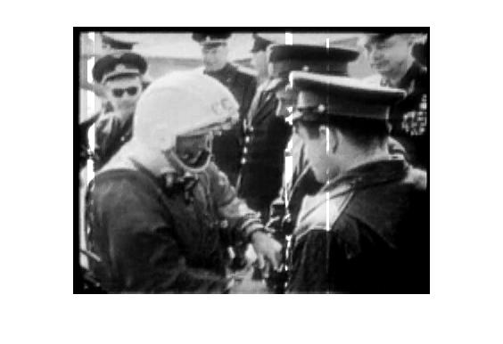

9.3 Reconstructed Frame 5

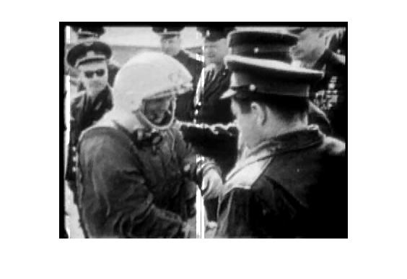

9.4 Reconstructed Frame 11

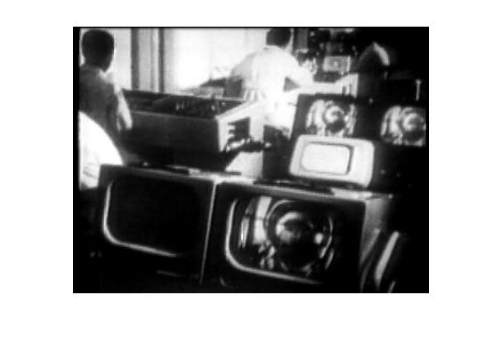

9.5 Reconstructed Frame 21

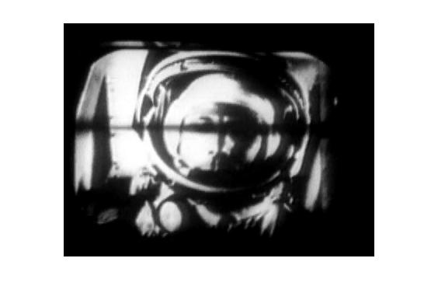

Results

10.1 Data Compression Ratio Calculation
Data compression ratio, also known as compression power, is a computer-science term used to quantify the reduction in data-representation size produced by a data compression algorithm.
The data compression ratio is analogous to the physical compression ratio used to measure physical compression of substances, and is defined in the same way, as the ratio between the uncompressed size and the compressed size

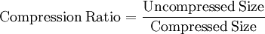
Actual amount of data to be transmitted = 352Kb * 27 frames
= 9,504Kb
After applying SAD algorithm on the frames, the amount of data (text files) to be transmitted is
Difference of Frames 1,2 = 39Kb
Hence, total amount of data for the difference frames = 1,014 Kb
Transmitted Amount = 352 Kb + 1014 Kb
= 1,366
Compression Ratio = 9,504 = 6.95
1,366

10.2 Savings Space Calculation
Sometimes the space savings is given instead, which is defined as the reduction in size relative to the uncompressed size

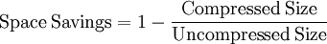

Space Savings = 1 – 1,366 = 9,504 – 1,366 = 85.62%
9,504 9,504

Conclusion

Bandwidth management is crucial when large data is involved. Videos occupying large memory cause problems because of limited hardware, this makes video compression essential.
In view of the above discussion video compression has become a major field of research. The number of papers on video compression in the last few years has been many and the number is still increasing.
In this project we have achieved video compression by using SAD algorithm. Video compression achieved by us is lossy— it operates on the premise that much of the data present before compression is not necessary for achieving good perceptual quality.
By using SAD as a metric, we can determine the amount of correlated data and thus eliminating the need for re-transmission of redundant data. Hence with SAD algorithm differences from one frame to the next are encoded as often a large number of the pixels will be the same on a series of frames.
From the result, we can observe that by applying the sad algorithm to the video, it is compressed to about 86% of its original size. The compression ratio is 6.95 which are almost the same as a JPEG encoded image.
The actual size of the video was 9.28Mb and it was compressed to 1.33Mb and hence about 7.95Mb of the bandwidth and space was saved.
Applications

11.1Applications of SAD algorithm
Apart from finding application in video compression, this algorithm can be used for
- Depth Matching
- Obstacle Detection (for e.g. On Highways)
- Prediction of human activities based on biometric sensors
- Location Detection in a wireless LAN infrastructure
- Scene interpretation
It is mainly used as a metric in motion estimation and hence such related applications.

11.2 Applications of Video Compression
- To transmit large amounts of data via terrestrial broadcast, cable TV or satellite TV
- In broadcasting signals
- Reduces the consumption of expensive resources such as hard disk space and so on….

Future Scope

The need for compression of data is needed everywhere. Whether it is for storing or transmitting or receiving or any other function, compressed data is preferred. To take this project further, one can try to make this lossy compression lossless by improvising on the SAD concept. Though the compression is lossy in this case, compression is more. Depending on the need and application, one can prefer either lossy or lossless compression.
If the need is for a lossy compression with a higher compression ratio, one can increase the threshold and then transmit those columns which are above the threshold. Another alternative is to add another form of encoding such as JPEG. One can take this compression to the next level by applying SAD with JPEG encoding to get a better compression ratio and better quality of the frame of the video.
If the need is for a lossless one, one can repeat the procedure given in this project with a higher threshold.

Bibliography

- FPGA-based Architecture for Real-Time IP Video and Image Compression - D. Maroulis, N. Sgouros, D. Chaikalis
- Hardware bidirectional real time motion estimator on a Xilinx Virtex II Pro FPGA - Rashid Iqbal
- A Sum of Absolute Differences Implementation in FPGA Hardware - Stephan Wong, Stamatis Vassiliadis, and Sorin Cotofana
- The Sum-Absolute-Difference Motion Estimation Accelerator – S. Vassiliadis, E.A. Hakkennes, J.S.S.M. Wong, G.G. Pechanek
- Sum of Absolute Differences – a journal by Motorola
- Performance Analysis of H.263 Video Encoder for VRAM – Thinh PQ Nguyen
- Evaluation of the Effect of Saturation Arithmetic and other Techniques on Sum of Absolute Differences (SAD) Computation in H.264 – Venkata Suman Sanikommu
- De-interlacing of Video Data – Fazzini, Paolo, Guiseppe
- Algorithms and VLSI Architectures for MPEG-4 Motion Estimation - Shahrukh Agha and Vincent M Dwyer
- Low-cost Temporal Interpolation of Video Frames – Emilio Antunez
- A System for Providing the Absolute Differences of Absolute Values – Mennemeier Larry, Peleg Alexander, Gottlieb Koby
- Measuring the Effectiveness of Image/Video Processing for Stabilizing a Video Image using a Commercial Media Player – Thomas E. Wett
- http://www.pinnaclesys.com/PublicSite/us/Home/
- VHDL programming by example – Douglas L. Perry
- A VHDL Primer – Jayaram Bhaskar

Appendix

14.1 MATLAB code to read the images and convert the gray scale values to binary and store the values in a text file
F1 = imread ('frame1.bmp');
F2 = imread('frame2.bmp');
C1 = F1; C2 = F2;
C1(:,:,1:1:2) = [ ];
C2(:,:,1:1:2) = [ ];
R1 = reshape(C1,1,nzmax(C1));
R2 = reshape(C2,1,nzmax(C2));
D = R1 - R2; A = abs(D);
m = nzmax (A);
l = 0; k = 0;
7fid = fopen ('F12.txt','w+b');
for h = 1:8:m
for i = h:(h+7)
l = dec2bin(A(i));
p = length(l);
while p<8
k = [48 l];
l = k;
p = p+1;
end
fprintf (fid, '%s\n', l);
end
end
fclose (fid);

14.2 VHDL code to read two files in MODELSIM
library std;
library ieee;
use ieee.std_logic_1164.all;
use std.textio.all;
entity frames is
port( en : in std_logic);
end frames;
architecture frames_a of frames is
begin
process(en)
file infile1 : text is in "C:\Modeltech_6.0\examples\work\F12.txt";
file outfile1: text is out "C:\Modeltech_6.0\examples\work\F12op.txt";
variable out_line1,in_line1 : LINE;
variable frameD : string(1 to 8) ;
variable nframeD : string(1 to 8) ;
begin
while not (endfile(infile1)) loop
readline (infile1,in_line1);
read (in_line1,frameD);
nframeD : = (frameD) ;
write(out_line1,nframeD);
writeline(outfile1,out_line1);
end loop;
end process;
end frames_a;

14.3 Package in VHDL to write the values from a text file into an array
library IEEE;
use IEEE.STD_LOGIC_1164.all;
use ieee.numeric_std.all;

package PKG1 is

constant TOTAL_VALUES : INTEGER := 12;
constant COUNT1 : INTEGER := 3;
constant COUNT2 : INTEGER := TOTAL_VALUES/COUNT1;
constant MEM_DEPTH : INTEGER := TOTAL_VALUES/COUNT1;
constant MEM_ADD_SIZE : INTEGER := 9;
constant THRESHOLD_WIDTH : INTEGER := 19;
-- constant THRESHOLD : STD_LOGIC_VECTOR(THRESHOLD_WIDTH-1 DOWNTO 0); --INTEGER := 306900;
constant MEM_DATA_WIDTH : INTEGER := 19;
constant DATA_WIDTH : INTEGER := 8;
constant CLK_PERIOD : TIME := 20 ns ;

end PKG1;

14.4 MATLAB program to calculate the threshold

F1 = imread(‘frame27_1.bmp’);
F2 = imread(‘frame27_2.bmp’);
F1(:,:,1:1:2) = [ ];
F2(:,:,1:1:2) = [ ];
D = F1 – F2;
S = sum(D);
M = max(S);
T = M * 0.75;
Th = dec2bin(T);

14.5 VHDL code to generate a clock

library IEEE;
use IEEE.STD_LOGIC_1164.all;
use ieee.numeric_std.all;

library WORK;
use WORK.PKG1.all;

entity CLKGEN is
port ( clk : out STD_LOGIC );
end CLKGEN;

architecture SIM of CLKGEN is

signal clk_s : STD_LOGIC;

begin

process
constant PERIOD : TIME := CLK_PERIOD ;
begin
clk_s <= '0';
wait for PERIOD/2;
clk_s <= '1';
wait for PERIOD/2;
end process;

clk <= clk_s;

end SIM;

14.6 Test bench in VHDL to filter the values based on a threshold
LIBRARY ieee;
USE ieee.std_logic_1164.ALL;
USE ieee.std_logic_arith.ALL;
USE ieee.std_logic_unsigned.ALL;

library WORK;
use WORK.PKG1.all;
USE STD.TEXTIO.ALL;

entity TB_core is
end TB_core;

architecture TB of TB_core is

component core
port( clk : in STD_LOGIC; -- clock signal
rst : in std_logic; -- reset signal
tsh_value : in std_logic_vector(THRESHOLD_WIDTH-1 downto 0);
din : in STD_LOGIC_VECTOR (DATA_WIDTH-1 downto 0);
en : in STD_LOGIC; -- Enable signal
mem_last_add : out integer range 0 to 400;
done_output : out std_logic;
mem_read_add : in integer range 0 to 400;
mem_dataout : out std_logic_vector(MEM_DATA_WIDTH-1 downto 0);
mem_read_en : in std_logic);
end component;

component CLKGEN
port ( clk : out STD_LOGIC );
end component;

constant FILEIN_NAME : STRING := "C:\Modeltech_6.0\examples\work\image.txt";

signal clk_i : std_logic;
signal rst_i : std_logic;
signal tsh_value_i : std_logic_vector(THRESHOLD_WIDTH-1 downto 0);
signal din_i : STD_LOGIC_VECTOR (DATA_WIDTH-1 downto 0);
signal en_i : STD_LOGIC;
signal done_output_i : std_logic;
signal mem_read_add_i : integer range 0 to 400;
signal mem_dataout_i : std_logic_vector(MEM_DATA_WIDTH-1 downto 0);
signal mem_read_en_i : std_logic := '0';
signal mem_last_add_i : integer range 0 to 400 := 0;
type bitfile is file of std_logic_vector (DATA_WIDTH-1 downto 0);
begin

core_inst : core port map (
clk => clk_i,
rst => rst_i,
tsh_value => tsh_value_i,
din=> din_i,
en=> en_i,
mem_last_add => mem_last_add_i,
done_output=> done_output_i,
mem_read_add => mem_read_add_i,
mem_read_en => mem_read_en_i,
mem_dataout => mem_dataout_i
);

clkgen_inst : CLKGEN port map ( clk => clk_i);

process
file infile : TEXT open read_mode is FILEIN_NAME;
VARIABLE inLine : LINE;
VARIABLE dataRead : bit_vector (DATA_WIDTH-1 downto 0);
begin
WAIT UNTIL clk_i = '1' AND clk_i'EVENT;
if (en_i ='1') then
if (NOT ENDFILE(infile)) then
READLINE(infile, inLine);
READ(inLine, dataRead);
din_i <= To_StdLogicVector(dataRead);
ELSE
wait;
END IF;

end if;
end process;

process
begin
rst_i <= '1';
en_i <= '0';
wait for 20 ns;
rst_i <= '0';
tsh_value_i <= "0000000000000001100";
wait for 20 ns;
en_i <= '1';
wait;
end process;
process (clk_i)
begin
if (clk_i'event and clk_i='1') then
if (done_output_i = '1') then
mem_read_en_i <= '1';
end if;
end if;
end process;

process (clk_i)
begin
if (clk_i'event and clk_i='1') then
if (mem_read_en_i = '1') then
if (mem_read_add_i < mem_last_add_i) then
mem_read_add_i <= mem_read_add_i + 1;
end if;
end if;
end if;
end process;

end TB;

14.7 Illustrative Text file in which the binary data is stored

1010100000
1010100001
1010100010
1010101001
1010101010
1010101011
1010100011
1010100100
1010100101
1010100110
1010100111
1010101000

